Name Geology 12 - 2023
TA
LG #6: Sedimentary & Metamorphic Rocks
BIG IDEA: Minerals, rocks, and earth materials form in response to conditions within and on the Earth’s surface and are the foundation of many resource-based industries.
Fundamental Knowledge (I know):
- Processes of sedimentary rock formation:
  - clastic sediments and chemical (precipitate or biochemical) sediments, and the rocks they become
  - relationships between depositional environments and particle size, shape, sorting, fossils, and organic structures
  - properties of common sedimentary rocks
  - sedimentary features including ones that affect porosity and permeability
- Processes of metamorphic rock formation:
  - relationships between the types and characteristics of metamorphic rocks and parent rock, temperature, pressure, and chemical conditions
  - properties of common metamorphic rocks
  - foliated and non-foliated rocks
  - contact versus regional metamorphism
  - metamorphic grade (e.g., with reference to coal)

Curricular Competencies (I can)
 | Proficiency Scale Teacher and Student self assessment  (Circle one) | Example | Evidence  (How do you know?)
Construct, analyze, and interpret graphs, models, and/or diagrams.  Analyze cause-and-effect relationships. | Emerging (C-/C)  Initial Understanding | Completed Activities #1 & #2 – Journal with fundamental knowledge and vocabulary (in your words).  Activity #3 is complete.
 | Developing (C+/B) Partial/Near Complete Understanding | Completed Activities #1 & #2 – Journal with fundamental knowledge and vocabulary (in your words with details).  Completed the suggested learning activities below (Activities #3 & #4)
 | Proficient (B+/A)  Complete Understanding | Completed Activities #1 & #2 – Journal with fundamental knowledge and vocabulary (in your words, with examples and diagrams, connecting to the main ideas).  Suggested activities (Activities #3 & #4) are thoroughly completed, provide details, use vocab that is related accurately and good resources.
 | Extending (A+) Sophisticated Understanding
Student Signature: Teacher Signature: Date:

Resources can be found at www.THSSscience.com
User: THSS
Password: science

LG 6 Sedimentary & Metamorphic Rocks

Suggested Learning Activities:

RESOURCES
1. Text: Physical Geology & the Environment
2. Online Resources: Videos
Sedimentary Rocks - https://www.youtube.com/watch?v=Etu9BWbuDlY
Metamorphic Rocks - https://www.youtube.com/watch?v=1oQ1J0w3x0o
The Rock Cycle - https://www.youtube.com/watch?v=Vp_S3BDiR-I

Activity #1: Journal
1. Refer to your text Physical Geology & the Environment Ch. 9 Sediments and Sedimentary Rocks. Read pages 222 – 239.
Alternatively, you can check out the online resources listed above and/or find your own to help research the definitions below.

2. In your journal:
- describe the processes involved in creating a sedimentary rock including: sediments, transportation, and lithification.

- Describe how the 3 different types of sedimentary rock are formed: clastic, chemical, and organic. Give examples of each rock type.

- Describe the different types of sedimentary structures and explain what they tell us about the environment in which they were formed: bedding, original horizontality, superposition, crossbedding, ripple marks, graded bedding, mud cracks and varves.

- Why are fossils commonly found in sedimentary rock and not igneous rock?

Activity #2 : Journal
1. Refer to your text Physical Geology & the Environment Ch. 10 Metamorphism, Metamorphic Rocks, and Hydrothermal Rocks. Read pages 252 -275.
Alternatively, you can check out the online resources listed above and/or find your own to help research the definitions below.

2. In your journal:
- Describe how a metamorphic rock forms.

- Describe what foliation is.

- Describe the following rocks: slate, phyllite, schist, gneiss, metaconglomerate, quartzite, marble.

- Compare and contrast contact and regional metamorphism.

- Describe the process of hydrothermal activity including hydrothermal vents (black smokers) and hydrothermal veins.

Activity #3: Types of Sedimentary Rocks - Vocabulary Word Scramble
1. Complete the worksheet found on page 4.

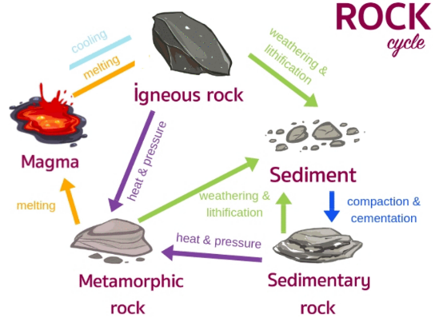
Activity #4: The Rock Cycle
Like most Earth materials, rocks are created and destroyed in cycles. The rock cycle is a model that describes the formation, breakdown, and reformation of a rock as a result of sedimentary, igneous, and metamorphic processes. All rocks are made up of minerals.

1. Using at least three (3) different materials, create a model that shows the different processes found in the rock cycle.
2. At minimum, label the types of rocks present in the rock cycle and the different processes they experience.

TYPES OF SEDIMENTARY ROCKS
Directions: Unscramble each of the clue words. Copy the letters in the numbered cells to other cells with the same number.

