Name Geology 12 - 2023
TA
LG #11: Streams and Groundwater
BIG IDEA: Weathering and erosion processes continually reshape landscapes through the
interaction of the geosphere with the hydrosphere and atmosphere

Fundamental Knowledge (I know):
- Weathering and erosion processes:
  - modifications of the Earth’s surface and production of characteristic features
  - chemical, physical, and biological weathering
  - erosion and deposition by rivers
- Groundwater and aquifers:
  - quality and quantity
  - water table, zone of saturation
  - effect of porosity and permeability on aquifer characteristics
  - artesian wells and springs
  - use of groundwater (e.g., urbanization, agriculture, sea-water contamination of groundwater, over-pumping)

Curricular Competencies (I can)
 | Proficiency Scale Teacher and Student self assessment  (Circle one) | Example | Evidence  (How do you know?)
Analyze cause-and-effect relationships.  Demonstrate a sustained intellectual curiosity about a scientific topic  or problem of personal, local, or global interest. | Emerging (C-/C)  Initial Understanding | Completed Activities #1 & #2 – Journal with fundamental knowledge and vocabulary (in your words).
 | Developing (C+/B) Partial/Near Complete Understanding | Completed Activities #1 & #2 – Journal with fundamental knowledge and vocabulary (in your words with details).  Completed the suggested learning activities below (Activities #3 & #4 – Choice A or B)
 | Proficient (B+/A)  Complete Understanding | Completed Activities #1 & #2 – Journal with fundamental knowledge and vocabulary (in your words, with examples and diagrams, connecting to the main ideas).  Suggested activities (Activities #3 & #4 – Choice A or B) are thoroughly completed, provide details, use vocab that is related accurately and good resources.
 | Extending (A+) Sophisticated Understanding
Student Signature: Teacher Signature: Date:

Resources can be found at www.THSSscience.com
User: THSS
Password: science

LG 11 Streams and Groundwater

Suggested Learning Activities:

RESOURCES
1. Text: Physical Geology & the Environment
2. Online Resources:
River formations from erosion and deposition - https://www.youtube.com/watch?v=JqFhmZc5Wis
River erosion demo - https://www.youtube.com/watch?v=IxlpDWItLPg
Hydrologic cycle - https://www.youtube.com/watch?v=ArBYU1SPZ48
Groundwater - https://www.youtube.com/watch?v=VtIY4FYWJV8
Groundwater contamination - https://www.youtube.com/watch?v=o4xjo_zAPJM
Geothermal energy - https://www.youtube.com/watch?v=DFQrE91kZwk

Activity #1: Journal
1. Refer to your text Physical Geology & the Environment Ch. 14 Streams and Floods. Read pages 355-387; Ch. 15 Groundwater. Read pages 390-416.
Alternatively, you can check out the online resources listed above and/or find your own to help research the definitions below.

2. In your journal:
- Using a diagram, describe the hydrologic cycle.
- Define the following terms: stream (specifically from a geoscientist’s point of view), stream channel, sheetwash, drainage basin, and tributary.
- Explain the difference between the four (4) different drainage patterns. Which is the most common?
- Describe the factors that affect stream erosion and deposition.
- Describe the many ways that streams transport sediment.
- List and briefly describe the different types of features that streams create by erosion and deposition.
- Define the following terms: downcutting, base level, lateral erosion, headward erosion, stream terraces and incised meanders.

Activity #2: Journal
1. Refer to your text Physical Geology & the Environment Ch. 15 Groundwater. Read pages 390-416.
Alternatively, you can check out the online resources listed above and/or find your own to help research the definitions below.

2. In your journal:
- Define what groundwater is.
- Explain the difference between “porosity” and “permeability”.
- Define the following terms: saturated zone, water table, unsaturated zone, and perched water table, aquifer, well, artesian well, and spring.
- Briefly describe how groundwater moves, what it is dependent on and what features it can form.
- Explain the difference between a “geyser” and “hot springs”.
- What is geothermal energy? List the pros and cons of using this type of energy resource.

Activity #3: Stages of a Stream Worksheet
1. Complete the questions on pages 4-9.

Name ____________________
Stages of a Stream
Directions: Read the following information on rivers and answer all the questions that follow.
Streams are created when excess water from rain, snowmelt, or near-surface groundwater accumulates on the ground surface and begins to run downhill. This excess water from rain or snowmelt generally occurs when the water accumulates at a faster rate than the soil and organic matter can absorb the water, plants can use it, or the water can be evaporated into the air.
Regardless of its water source, a stream follows the lowest places in the landscape, joining other tributaries from other low spots on the landscape. These small first-order and second-order streams may in turn join larger third-order streams, and so on, creating a dendritic drainage network within the watershed.
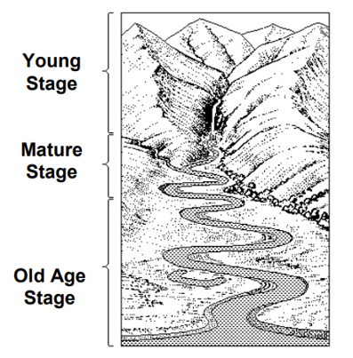
As the smaller streams join one another, the accumulated water's quantity and velocity increase, and the water begins to cut into Earth's surface, creating its own pathway. With time and differing flows, the stream modifies its pathway. This may cause problems for people who have assumed that the stream will keep to its original path. But the stream plays a balancing act among the volume of water it carries, the amount of sediment available, and the ground it must traverse.
Streams slowly change their characteristics over time in response to changes in elevation, gradient, volume of water, and available sediments. There are three main stages of a stream:
The Young Stage:
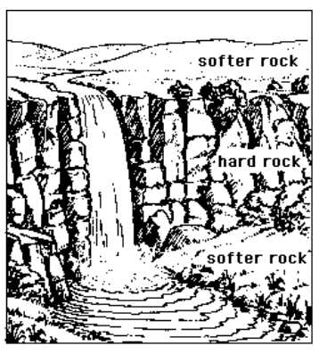
This stage represents the early stages of a stream where most of its energy is used to downcut, or erode, a narrow V-shaped valley. This is a valley whose typical cross-section is shaped like a 'v' (a cross-section is the shape that you would walk if you walked down one side of a valley and up the opposite side). A V-shaped valley has steep sides and a narrow floor. Vertical erosion by the stream deepens the valley floor. Weathering and gravity cause material to be worn away and tumble down the valley side. During this stage the ground over which the stream flows has a steep slope with many abrupt changes in elevation resulting in waterfalls and rapids.
A waterfall is a steep drop in the bed of a stream causing the water in the stream to fall vertically. Waterfalls occur where a band of harder rock crosses the path of a stream. The stream is less able to erode this harder rock and leaves it as a step in the stream's long profile (Fig.1). Due to the steep gradient of this stage water velocity is very fast. Fast moving water can carry larger sized sediments like boulders and cobbles.
The Mature Stage:
Further downstream, water added to the stream from tributaries and from ground water increases the size, or width, of the stream. The slope during this stage decreases and so does the velocity of the water flowing through the stream. Since the water velocity has decreased the stream no longer has enough energy to carry boulders and cobbles. The largest sediments the stream can now carry are pebbles and sand. Due to the increase in width, the stream begins to shift its course in a series of bends or turns called meanders.
As the water flows down a stream, its speed is faster on the outside of the meander causing erosion and slower on the inside of the meander resulting in deposition. This is how meanders are created (Fig. 2). During times of flooding, when the stream overflows its banks, it deposits, or releases, sediments. Each time this occurs a thin layer of fine material is laid down on both sides of the river forming a flood plain (Fig. 3). During this stage a very narrow flood plain forms.

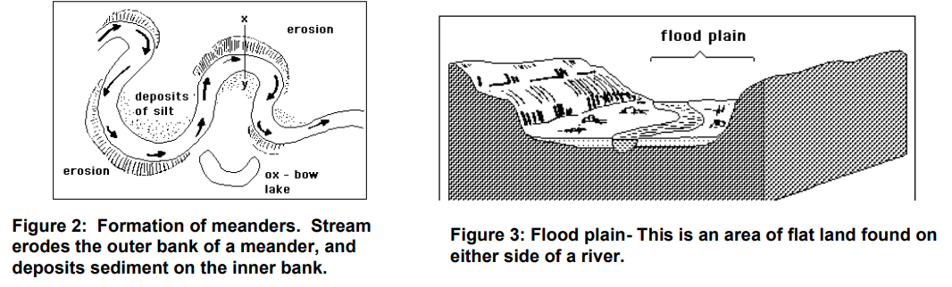

The Old Age Stage:
A stream greatly slows down in its oldest stage and begins to cut, or erode, a very wide valley and an equally wide flood plain. Since the water velocity has further decreased from the previous stage it no longer has enough energy to carry pebbles and sand. Now it can only carry smaller sized sediments like silt. This stage also possesses meanders which curve even more than in the mature stage. Due to the larger size of these meanders ox-bow lakes are often seen. An oxbow lake is a horseshoe lake found on the flood plain of a stream (Fig.4). Meanders may form a loop so that only a narrow neck of land separates their outer banks. In a heavy flood the stream cuts through this neck leaving the loop as a cut-off. This cut-off section becomes an ox-bow lake.
During this older stage the stream usually comes to an end when the flow enters a sea or lake. This is known as the mouth of the stream. Where a river meets the sea or a lake the ground is virtually flat, so its speed slows down and it deposits, or releases, all of the sediments it was carrying. This leads to a fan-shaped deposit extending out to sea called a delta (Fig.5).

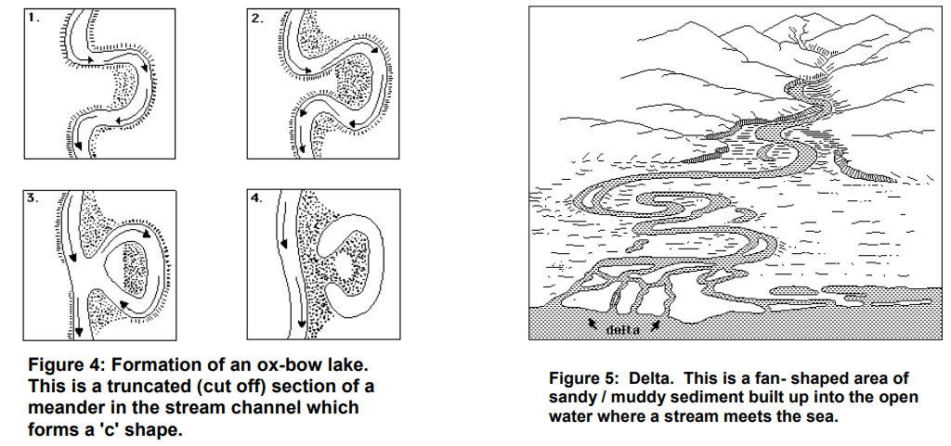

_____________________________________________________________________________________
Reading for Meaning
Part 1 Directions: Based on the reading, decide if you agree or disagree with the following statements. Be sure to quote the part of the reading that helped you form this opinion.

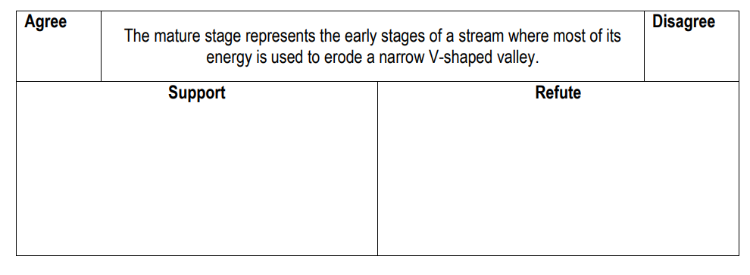

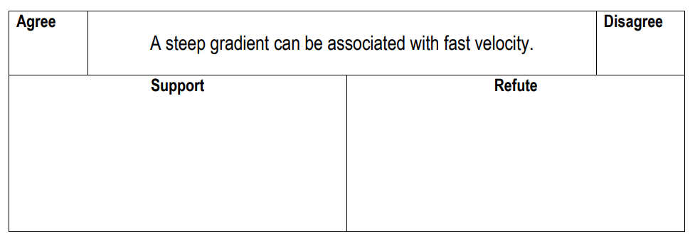
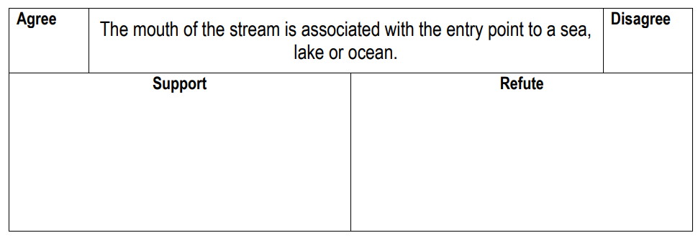

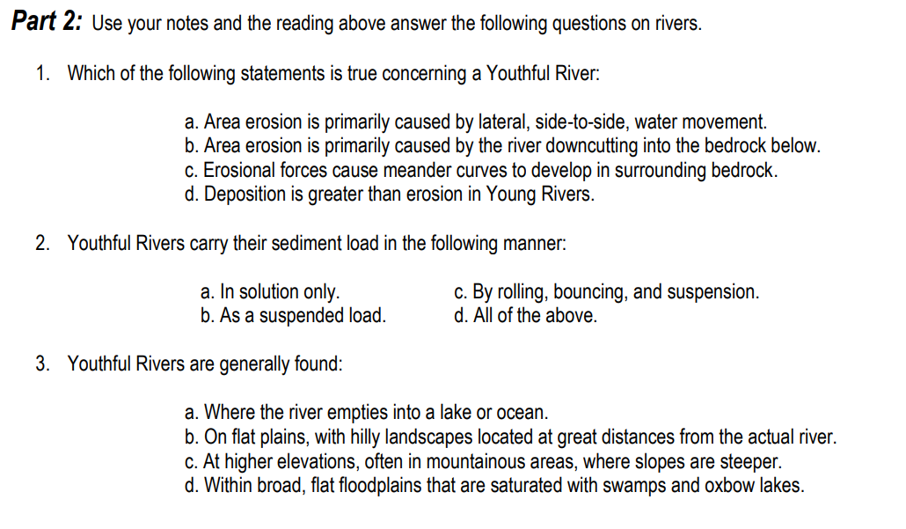
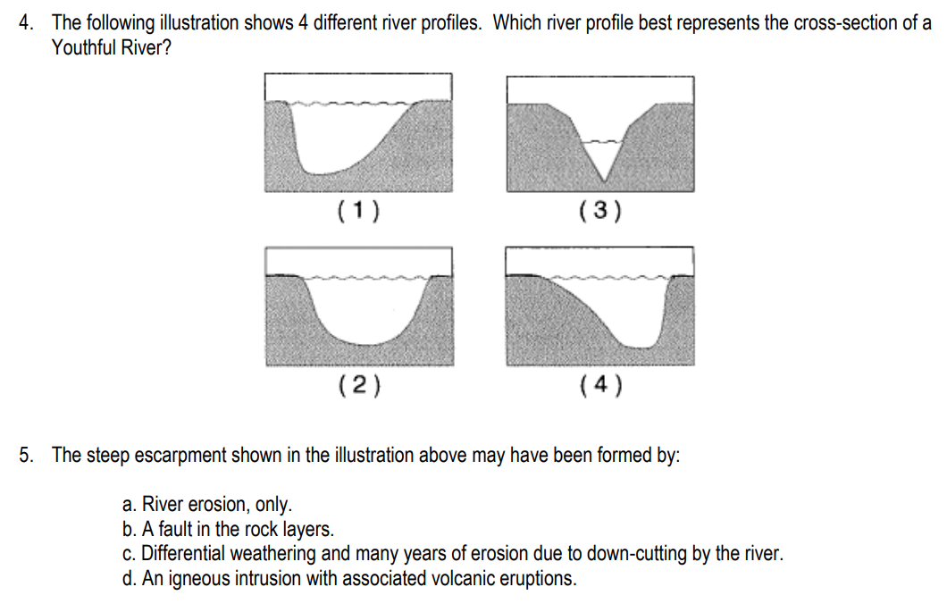

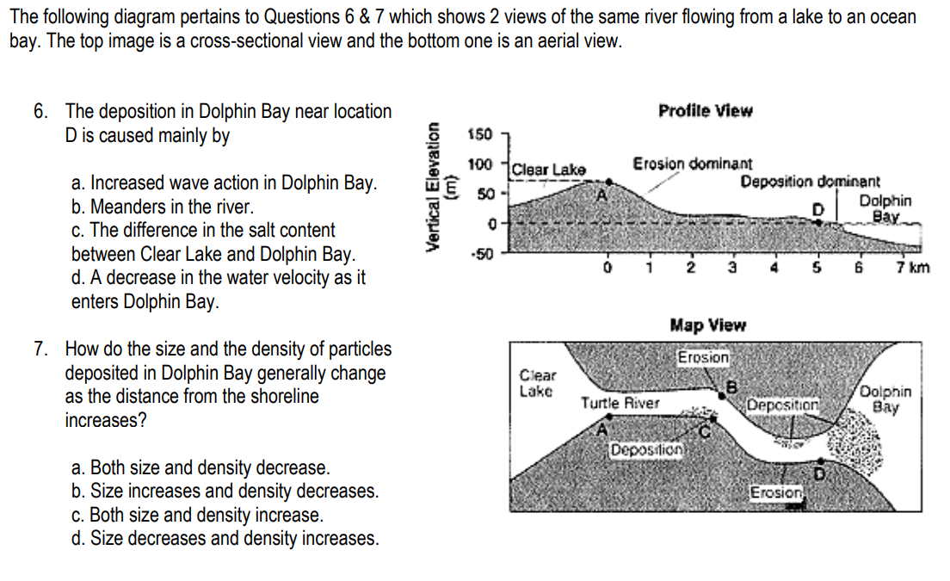
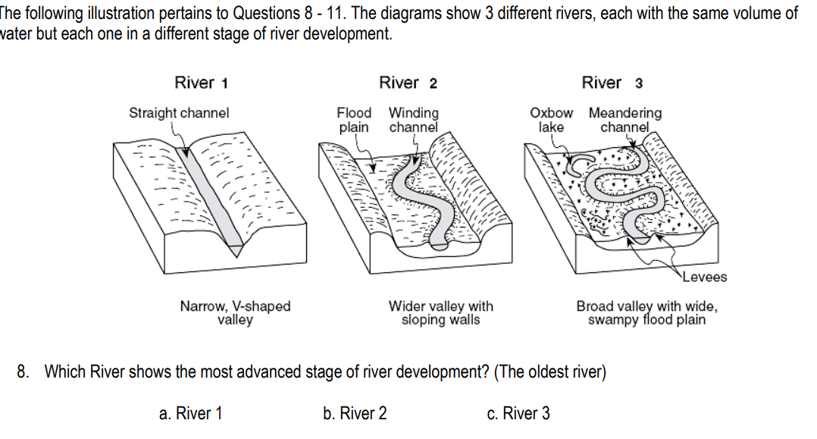
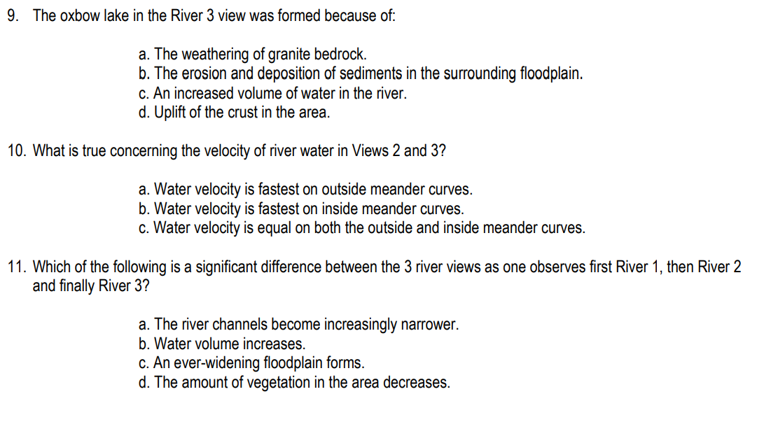

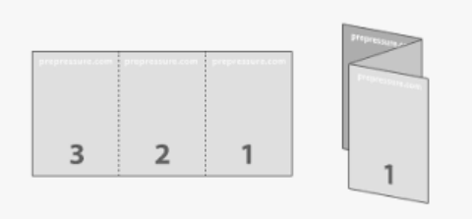
Activity #4: Groundwater Tri-fold Brochure

CHOICE A – Quality Checking
Groundwater can be contaminated by many sources. Your task is to create a tri-fold brochure to share the information you find about how groundwater is contaminated, how we can determine the quality and ways we can remediate and/or keep our water sources clean.

1. Identify at least three (3) types of groundwater contamination sources and list the effects this may have on the environment and society around us.
2. Find and list a minimum of four (4) water quality testing methods that are currently used today to confirm whether the water we are accessing is safe for use. Be specific when defining what each test can tell us about the water quality. Which test do you think is the most useful / important?
3. Include two (2) ways that we can keep our water sources clean.
4. Be sure to add your creative zing to your brochure (colour, pictures, drawings, etc.)!

CHOICE B – How is it Used?
Groundwater is used in many ways! Your task is to create a tri-fold brochure to share the information you find about the ways in which groundwater is used on Earth & the issues encountered in maintaining this resource.

1. Identify at least four (4) uses of groundwater and why these are important to our needs / wants as a society.
2. Find and list three (3) effects that groundwater depletion has on our environment and society. Which do you believe is the most negative effect (long-term or short-term)?
3. Include two (2) ways that we can keep our water sources clean.
4. Be sure to add your creative zing to your brochure (colour, pictures, drawings, etc.)!

