Name Geology 12 - 2023
TA
LG #10: Weathering and Erosion Processes
BIG IDEA: Weathering and erosion processes continually reshape landscapes through the
interaction of the geosphere with the hydrosphere and atmosphere

Fundamental Knowledge (I know):
- Weathering and erosion processes:
  - modifications of the Earth’s surface and production of characteristic features
  - mass movements (slide, soil creep)
  - controls of mass wasting: for example, drainage, installation of perforated pipe
  - chemical, physical, and biological weathering
  - weathering potential of minerals in Bowen’s reaction series (e.g., stability of quartz)

Curricular Competencies (I can)
 | Proficiency Scale Teacher and Student self assessment  (Circle one) | Example | Evidence  (How do you know?)
Construct, analyze, and interpret graphs, models, and/or diagrams.  Demonstrate a sustained intellectual curiosity about a scientific topic  or problem of personal, local, or global interest.  Analyze cause-and-effect relationships. | Emerging (C-/C)  Initial Understanding | Completed Activity #1 – Journal with fundamental knowledge and vocabulary (in your words).  Activity #2 is complete.
 | Developing (C+/B) Partial/Near Complete Understanding | Completed Activity #1 – Journal with fundamental knowledge and vocabulary (in your words with details).  Completed the suggested learning activities below (Activities #2 & #3 – Choice A or B)
 | Proficient (B+/A)  Complete Understanding | Completed Activity #1 – Journal with fundamental knowledge and vocabulary (in your words, with examples and diagrams, connecting to the main ideas).  Suggested activities (Activities #2 & #3 – Choice A or B) are thoroughly completed, provide details, use vocab that is related accurately and good resources.
 | Extending (A+) Sophisticated Understanding
Student Signature: Teacher Signature: Date:

Resources can be found at www.THSSscience.com
User: THSS
Password: science

LG 10 Weathering and Erosion Processes

Suggested Learning Activities:

RESOURCES
1. Text: Physical Geology & the Environment
2. Online Resources:
Weathering & erosion - https://www.youtube.com/watch?v=qGw1yB10lX0
Soil formation - https://www.youtube.com/watch?v=x7pmsCL6Ytc
Mass wasting / Mass movement - https://www.youtube.com/watch?v=RCxvbosa4fU&t=13s
https://www.youtube.com/watch?v=Egq6wS5wAUA

Activity #1: Journal
1. Refer to your text Physical Geology & the Environment Ch. 8 Weathering and Soil. Read pages 202-220; Ch. 13 Mass Wasting. Read pages 330-353.
Alternatively, you can check out the online resources listed above and/or find your own to help research the definitions below.

2. In your journal:
- Describe the difference between weathering and erosion.
- Describe the difference between mechanical weathering and chemical weathering.
- Explain the different types of mechanical (physical) weathering.
- Describe the different ways that the climate can affect weathering?
- Describe the role of water in chemical weathering.
- Describe what “soil horizons” are. Briefly explain the differences between the A, B & C horizon layers.
- Describe what mass wasting is and how it is classified.
- Explain the relationship between shear force and shear strength with respect to mass wasting.
- List the different types of triggering mechanisms for mass wasting events.
- Describe the difference between debris slides and debris falls.

Activity #2: Weathering & Erosion Worksheet
1. Complete the questions on pages 3-5.

Weathering & Erosion Worksheet

Base your answers on the data table and graph below.
Samples of three different rock materials, A, B, and C were placed in three containers of water and shaken vigorously for 20 minutes. Every five minutes, the rocks were strained through a screen. The mass of the rock materials trapped by the screen were dried and their mass was measured. This is the data table:
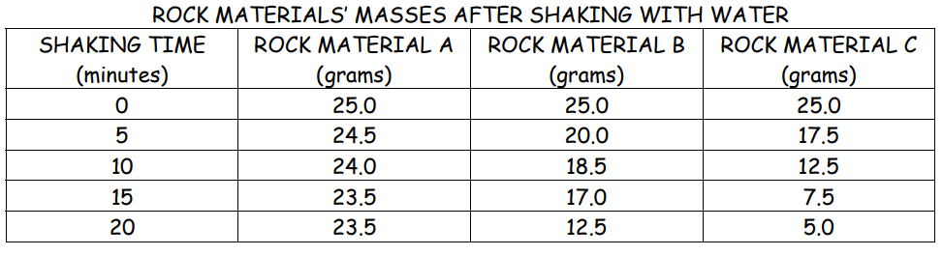
The data for Rock Material A and Rock Material B is graphed below:
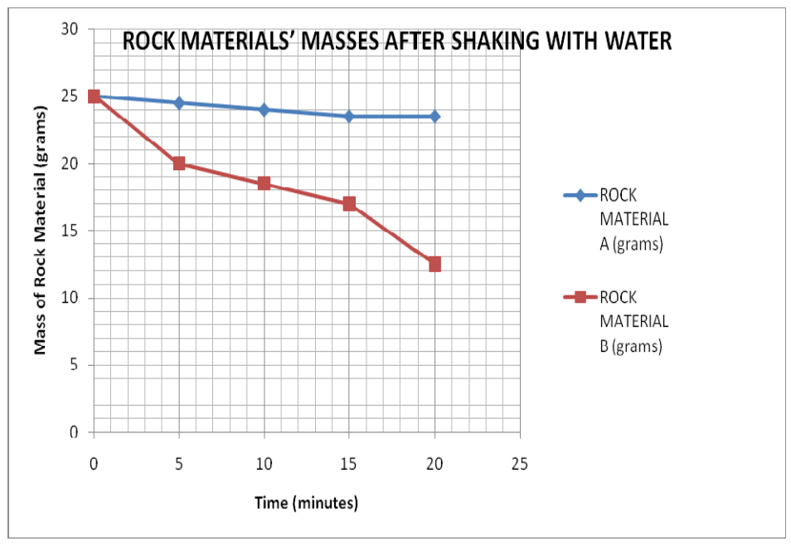
Review the data and answer the following questions:

1. Graph the data for Rock Material C on the graph above. Use points and surround each point with a small circle. Connect the points:

6. Refer to the graph. Which sample (A, B, or C) lost the most mass in the first five minutes? Which sample lost the most mass in the last five minutes?

-most in the first five minutes: ______________________

-most in the last five minutes: _______________________

7. What are the most likely reasons for the differences in the rate (speed) that mass was
lost in the three rock samples?

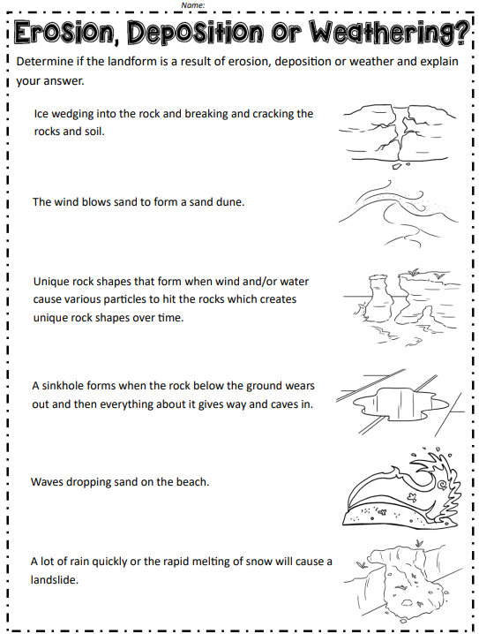

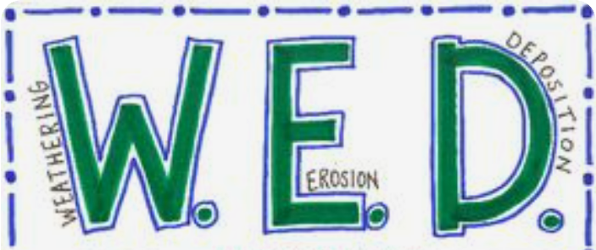
Activity #3: Mass Wasting Inquiry

CHOICE A: Examples of weathering, erosion, or deposition in your neighborhood.
Explore your local environment and find examples of weathering, erosion, or deposition. Aim to fill a one-page space in Word, or one PowerPoint slide, etc.

1. Identify and describe at minimum three (3) examples.
2. Include visual representations (could be a photo, picture, drawing, etc.) of your examples.
3. Describe what processes of weathering, erosion and/or deposition are occurring in each example.
4. If we lived in a different climate, would the same outcomes happen for each of your examples? Explain.

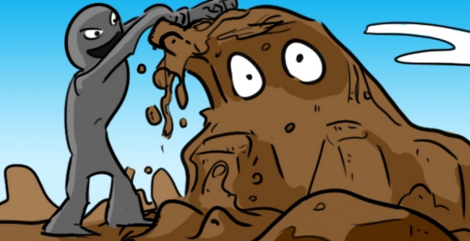
CHOICE B: Create Your Own News Article
Make your own news article on a mass wasting event (can be recent or historic). Your article should be between 250 - 400 words in length.

1. Consider including details to the following questions:
- How many people does / did it affect?
- Where did it happen?
- What type of mass wasting event was it?
- What was the cause(s) of the mass wasting event?
- Where any precautions in place at the time of the event? Where any added afterwards (or suggested)?

2. Include a picture / photo of the mass wasting event for your article.

3. Be sure to reference any resources used for your article.

