Name Geology 12 - 2023
TA
LG #8: Geologic Time, Fossils & Dating
BIG IDEA: Earth’s geological and biological history is interpreted and inferred from information stored in rock strata and fossil evidence.

Fundamental Knowledge (I know):
- Major events in Earth’s history: for example, formation of oldest rocks, earliest recorded life, domination of invertebrates, first land plants, domination of reptiles, appearance of flowering plants, Rocky Mountain orogeny, mass extinctions
- Fossil record: for example, Foraminifera, Mollusca, Brachiopoda, Echinodermata, Arthropoda (trilobites), Coelenterata (corals), Vertebrata, Graptolithina, Conodonta, algae, plants, reptiles
- Evidence of evolution: changes found in the fossil record over time as evidence for natural selection, adaptive radiation, and punctuated equilibrium
- Relative and absolute dating:
  - absolute dating using radioactive isotopes
  - principles of relative dating (e.g., superposition, unconformities, cross-cutting, index fossils, law of faunal succession)

Curricular Competencies (I can)
 | Proficiency Scale Teacher and Student self assessment  (Circle one) | Example | Evidence  (How do you know?)
Use knowledge of scientific concepts to draw conclusions that are consistent with evidence.  Analyze cause-and-effect relationships. | Emerging (C-/C)  Initial Understanding | Completed Activity #1 – Journal with fundamental knowledge and vocabulary (in your words).  Activity #2 is complete.
 | Developing (C+/B) Partial/Near Complete Understanding | Completed Activity #1 – Journal with fundamental knowledge and vocabulary (in your words with details).  Completed the suggested learning activities below (Activities #2 & #3)
 | Proficient (B+/A)  Complete Understanding | Completed Activity #1 – Journal with fundamental knowledge and vocabulary (in your words, with examples and diagrams, connecting to the main ideas).  Suggested activities (Activities #2 & #3) are thoroughly completed, provide details, use vocab that is related accurately and good resources.
 | Extending (A+) Sophisticated Understanding

Student Signature: Teacher Signature: Date:

Resources can be found at www.THSSscience.com
User: THSS
Password: science

LG 8 Geologic Time, Fossils & Dating

Suggested Learning Activities:

RESOURCES
1. Text: Physical Geology & the Environment
2. Online Resources:
Geologic Time - https://www.youtube.com/watch?v=rWp5ZpJAIAE
Fossil Record - https://www.youtube.com/watch?v=bRuSmxJo_iA
https://www.youtube.com/watch?v=ID7qhn1ipmw
Relative & Absolute Dating - https://www.youtube.com/watch?v=rWp5ZpJAIAE
Evidence of evolution - https://www.youtube.com/watch?v=CGFEJRjUh2g

Activity #1: Journal
1. Refer to your text Physical Geology & the Environment Ch. 19 Time and Geology. Read pages 510-535.
Alternatively, you can check out the online resources listed above and/or find your own to help research the definitions below.

2. In your journal:
- Define what “uniformitarianism” is.
- Explain what the difference is between relative age and absolute age.
- Using diagrams, explain the following relative dating techniques: original horizontality, superposition, cross-cutting relationships, included fragments (inclusion).

- Define: unconformity, correlation, and faunal succession.
- Describe how the Geologic Time Scale is structured.
- Describe how isotopic dating can determine the approximate age of a rock.
- Explain the concept of “half-life”.
- Describe the advantages and disadvantages of Potassium-Argon, Rubidium-Strontium, Uranium-Lead and Carbon 14 dating methods.

- Identify the era when the following developed: one-celled organisms, fish, amphibians, dinosaurs, birds, reptiles, and mammals.

Activity #2: The Law of Superposition Worksheet
1. Complete the worksheet found on page 5.

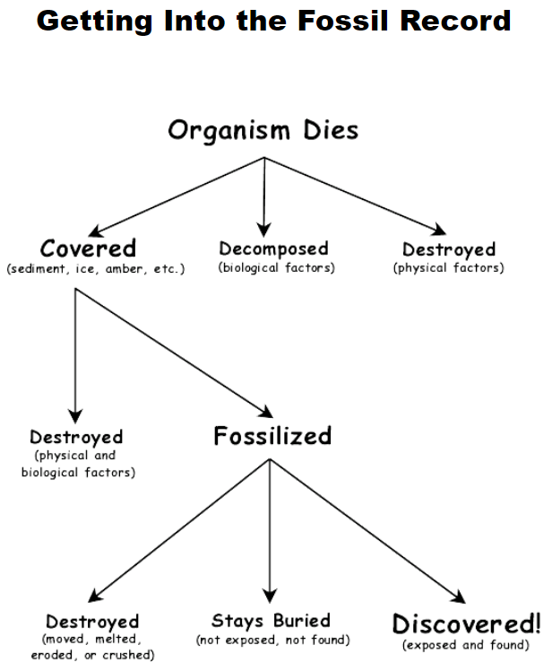
Activity #3: Fossil Record Inquiry
Directions – Using a variety of sources, answer the following questions shown below.

1. What kinds of questions can the fossil record help us to answer?

2. Describe the difference between a body fossil and a trace fossil.

3. Why are organisms that are buried rapidly more likely to fossilize than those that are buried slowly or not at all?

4. Describe two ways an organism can become a fossil without being buried in sediment.

Activity #3: Fossil Record Inquiry (cont.)
5. How does the environment affect the formation of fossils?

6. Describe three factors that could prevent an organism from long ago from ever turning up in a fossil collection today.

7. In your own words, explain why the fossil record is not complete.

BONUS: You have been hired by National Geographic Magazine to journey to Inner Mongolia in search of fossils. You have the good fortune to find a site filled with many fossilized leaves, teeth, bones, eggs and even footprints from a variety of creatures. Amidst this treasure trove of ancient life, you find no trace of insects. Your research partner concludes that no insects lived here at that time. What other hypothesis might you suggest to your partner?

