Name Geology 12 - 2023
TA
LG #7: Resource Deposits & Considerations
BIG IDEA: Minerals, rocks, and earth materials form in response to conditions within and on the Earth’s surface and are the foundation of many resource-based industries.
Fundamental Knowledge (I know):
- Resource deposits - resources in the local area:
  - hydrothermal and volcanogenic ore deposits
  - placer and surficial deposits
  - oil, liquid natural gas (LNG), coal, and other fossil fuels
- Economic, environmental, and First Peoples considerations:
  - role of geochemical or geophysical data in locating geological resources
  - factors used to determine economic feasibility of extracting a geologic resource (e.g., price, concentration, accessibility, size, environmental impacts)
  - uses of geologic resources in B.C.
  - current resource conflicts (e.g., pipelines, oil sands, open-pit mines)

Curricular Competencies (I can)
 | Proficiency Scale Teacher and Student self assessment  (Circle one) | Example | Evidence  (How do you know?)
Consider social, ethical, and environmental implications of the findings from their own  and others’ investigations.  Analyze cause-and-effect relationships. | Emerging (C-/C)  Initial Understanding | Completed Activity #1 – Journal with fundamental knowledge and vocabulary (in your words).
 | Developing (C+/B) Partial/Near Complete Understanding | Completed Activity #1 – Journal with fundamental knowledge and vocabulary (in your words with details).  Activity #2 complete.
 | Proficient (B+/A)  Complete Understanding | Completed Activity #1 – Journal with fundamental knowledge and vocabulary (in your words, with examples and diagrams, connecting to the main ideas).  Activity #2 is thoroughly completed, provide details, use vocab that is related accurately and good resources.
 | Extending (A+) Sophisticated Understanding

Student Signature: Teacher Signature: Date:

Resources can be found at www.THSSscience.com
User: THSS
Password: science

LG 7 Resource Deposits & Considerations

Suggested Learning Activities:

RESOURCES
1. Text: Physical Geology & the Environment
2. Online Resources:
B.C. map of resources - https://mineralsed.ca/site/assets/files/3453/minbcmap_me2013.pdf
Geological resources - https://www.youtube.com/watch?v=75NEel5rWpI
Oil & Gas formation - https://www.youtube.com/watch?v=8YHsxXEVB1M

Activity #1: Journal
1. Refer to your text Physical Geology & the Environment Ch. 12 Geologic Resources. Read pages 298-329.
Alternatively, you can check out the online resources listed above and/or find your own to help research the definitions below.

2. In your journal:
• Explain the difference between renewable and non-renewable resources.
• Explain how oil and gas form.
• Describe where we might find oil and gas.
• Describe the different types of coal, how they are formed and where they are found.
• Describe some of the environmental effects of extracting oil, gas, and coal in general.
• Describe the following methods of ore formation: Hydrothermal fluids, contact metamorphism, hydrothermal veins, disseminated deposits, placer deposits.
• Describe the differences between strip mines, open-pit mines, and underground mines.
• Identify the uses of and the ores used to produce the following: iron, copper, lead, zinc, gold, construction materials.

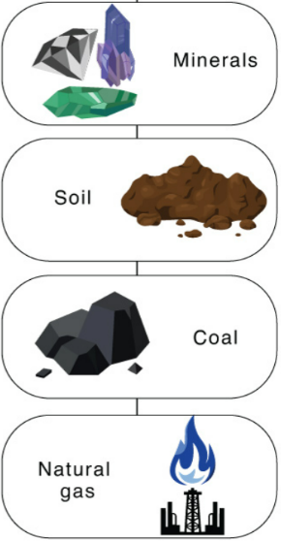
Activity #2: Resource Extraction & Considerations
Create a poster using the program of your choice (a single page Word or slide in PowerPoint is recommended). You will investigate a resource, how it is used and how it is mined / extracted. You will also discuss the impact this resource use has on society.

1. Choose from the following list of minerals and geologic resources that we currently mine in B.C.
- Copper  - Gold  - Zinc  - Molybdenum  - Silver  - Lead  - Jade | - Coal  - Oil  - Liquid natural gas (LNG)  - Gypsum  - Magnetite  - Limestone  - Sulfur

2. On your poster include the following:
- How the resource is currently used

- If the resource is renewable or non-renewable
  - If non-renewable, state any renewable alternatives

- How the resource is typically mined
  - Primary location(s) where the resource is found

- The environmental and societal impacts or side effects of the technique(s) used
  - Consider the impacts (direct & indirect) of resource development on First Peoples communities and traditional territories

- Make sure you cite any resources you may use in the appropriate format, including pictures.
  - You can use a separate page or slide to list your references on, so you don’t take away space from your poster.

- Make sure your name is on the document before saving.

