Name Geology 12 - 2023
TA
LG #4: Minerals
BIG IDEA: Minerals, rocks, and earth materials form in response to conditions within and on the Earth’s surface and are the foundation of many resource-based industries.

Fundamental Knowledge (I know):
  - Classification of minerals (composition, properties, structure)

Curricular Competencies (I can)
 | Proficiency Scale Teacher and Student self assessment  (Circle one) | Example | Evidence  (How do you know?)
Use knowledge of scientific concepts to draw conclusions that are consistent with evidence.  Express and reflect on a variety of experiences, perspectives, and worldviews through place. | Emerging (C-/C)  Initial Understanding | Completed Activity #1 – Journal with fundamental knowledge and vocabulary (in your words).  Activity #2 - Mineral ID Lab complete with observations and questions.
 | Developing (C+/B) Partial/Near Complete Understanding | Completed Activity #1 – Journal with fundamental knowledge and vocabulary (in your words with details).  Activity #2 - Mineral ID Lab complete with detailed observations and thoughtful questions.  Activity #3 – Complete either Choice A or B.
 | Proficient (B+/A)  Complete Understanding | Completed Activity #1 – Journal with fundamental knowledge and vocabulary (in your words).  Activity #2 - Mineral ID Lab complete with detailed, organized, and thoughtful observations, questions, and conclusion (back up your ideas with reference information).  Activity #3 – Complete either Choice A or B. Activities are thoroughly completed, provide details, accurately use vocab that is related, use good sources.
 | Extending (A+) Sophisticated Understanding

Student Signature: Teacher Signature: Date:

Resources can be found at www.THSSscience.com
User: THSS
Password: science

LG 4 Minerals

Suggested Learning Activities:

RESOURCES
1. Text: Physical Geology & the Environment
2. Online Resources: Minerals info and video
https://opengeology.org/historicalgeology/tools-of-historical-geology/earth-materials-mineral-identification/

Activity #1: Journal
1. Refer to your text Physical Geology & the Environment Ch. 5 Atoms, Elements and Minerals. Read pages 128 – 130, “In Greater Depth 5.4” on the top of page 136, the paragraph on page 135 which contains the words “Silica” and “Silicates”, the paragraph under the heading “Non-Silicate Minerals” on page 139, pages 140 – 152 (starting with “How do we Identify Minerals”).
Alternatively, you can check out the online resources listed above and/or find your own to help research the definitions below.

2. In your journal:
- Define what a mineral is.

- Describe the different types of minerals: silicates, and the following non-silicates: carbonates, sulphides, oxides, chlorides, and native elements.

- Describe how the following properties are used to identify minerals: colour, streak, hardness, crystal form, cleavage, fracture, specific gravity, special properties, and chemical tests.

Activity 2: Mineral Identification Lab
1. From the science kiosk, sign up & complete the mineral identification lab.

Activity# 3: Mineral Inquiry Assignment

CHOICE A
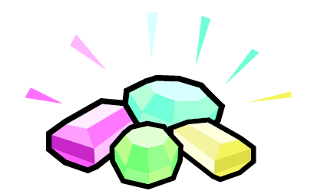
Design Your Own Bling
You are world-famous jewelry designer who designs grills, pendants, earrings, rings, watches, and bracelets for the hottest stars.
You are ready to design something new, something that no one has ever seen before.
1. Draw your new design.
2. You can make anything you want, but it must be made from:
a) at least FIVE (5) DIFFERENT MINERALS
AND include
b) at least ONE (1) LOCAL MINERAL found here in British Columbia, Canada
3. Your drawing must be colored.
4. You will also need to label the 5 minerals you used and explain why you chose those minerals.

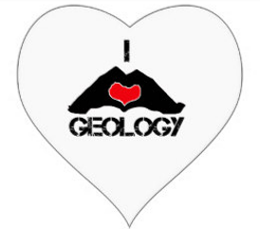
CHOICE B
Mineral Dating Profile
You are going to create a mock dating profile for a mineral! <3 <3 <3
Every online profile is broken down into blocks of text, pictures, links,
and other fun facts. For this assignment, you will use the following sections.*
Sections of a Dating Profile (1-5):
1. Screen Name: Invent a screen name for your mineral. It should be creative and relate to your mineral’s name or properties.
2. Profile Pic: Draw a picture/cartoon of your mineral. Get creative! Try to accurately show the shape, color, and other properties of your mineral.
3. Quote: Choose a quotation that fits the personality of your mineral. On Social Media profiles, users can put in a famous quote or song lyric or a goofy phrase to display under their photo. Choose a quote for your mineral; come up with something on your own or you might pick something from a movie or a song.

4. Physical Properties: In this section your mineral is showing off its best physical properties. Physical properties are determined by the mineral’s internal arrangement of atoms. In this section include:

- Chemical Formula (what elements it’s made of)
- Hardness
- Specific Gravity (density)
- Color
- Transparency
- Streak
- Luster
- Cleavage/Fracture
- Notable Occurrences (where is it known to be found in the world)
5. About Me: In this section your mineral is showing off why it’s unique and important.
- Describe your minerals distinguishing characteristics, what are some of its special properties?
  - Is it magnetic? Does it bubble with acid?
- Describe what your mineral is used for.
  - Is it important in making jewelry? Cosmetics? Technology?

*Use the Mineral Dating Profile Template on the next page.

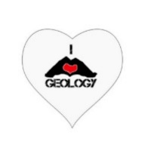
Screen Name: ______________________________________
Physical Properties:
Chemical Formula:
Hardness:
Specific Gravity:
Color:
Transparency:
Streak:
Luster:
Cleavage:
Fracture:

Notable Occurrences:

GEOmatch.com
Quote:

About Me:

