Name Geology 12 - 2023
TA
LG #12: Glaciers
BIG IDEA: Weathering and erosion processes continually reshape landscapes through the
interaction of the geosphere with the hydrosphere and atmosphere

Fundamental Knowledge (I know):
- Weathering and erosion processes:
  - modifications of the Earth’s surface and production of characteristic features
  - erosion by water, gravity, and ice
- Periods of glaciation:
  - characteristic erosional and depositional features and landforms
  - causes and frequency

Curricular Competencies (I can)
 | Proficiency Scale Teacher and Student self assessment  (Circle one) | Example | Evidence  (How do you know?)
Collaboratively and individually plan, select, and use appropriate investigation  methods, including field work and lab experiments, to collect reliable data  (qualitative and quantitative).  Analyze cause-and-effect relationships. | Emerging (C-/C)  Initial Understanding | Completed Activity #1 – Journal with fundamental knowledge and vocabulary (in your words).  Activity #2 complete – Glacier PhET Lab
 | Developing (C+/B) Partial/Near Complete Understanding | Completed Activity #1 – Journal with fundamental knowledge and vocabulary (in your words with details).  Completed the suggested learning activities below (Activities #2 & #3 – Choice A or B)
 | Proficient (B+/A)  Complete Understanding | Completed Activity #1 – Journal with fundamental knowledge and vocabulary (in your words, with examples and diagrams, connecting to the main ideas).  Suggested activities (Activities #2 & #3 – Choice A or B) are thoroughly completed, provide details, use vocab that is related accurately and good resources.
 | Extending (A+) Sophisticated Understanding
Student Signature: Teacher Signature: Date:

Resources can be found at www.THSSscience.com
User: THSS
Password: science

LG 12 Glaciers

Suggested Learning Activities:

RESOURCES
1. Text: Physical Geology & the Environment
2. Online Resources:
Understanding glaciers - https://www.youtube.com/watch?v=HEStq4VYJ2Y
https://climate.nasa.gov/news/3038/the-anatomy-of-glacial-ice-loss/
Permafrost - https://news.un.org/en/story/2022/01/1110722
https://www.youtube.com/watch?v=YegdEOSQotE&t=91s

Activity #1: Journal
1. Refer to your text Physical Geology & the Environment Ch.16 Glaciers , Glaciation and Permafrost. Read pages 419-452.
Alternatively, you can check out the online resources listed above and/or find your own to help research the definitions below.

2. In your journal:
- Define the following terms: glacier, alpine glaciation, continental glaciation, the theory of glacial ages, ablated and icebergs.
- Explain the difference between a valley glacier and an ice sheet or ice cap. Which glacier type is the most found in Canada?
- Describe the features that are produced by glacial erosion and glacial deposition.
- Describe what a “glacial budget” is and what it means to have a “balanced budget”.
- Define the following terms: zone of accumulation, zone of ablation, equilibrium line, crevasses, and rock flour.
- Explain, with examples, how permafrost is affected by climate change.

Activity #2: Glacier PhET Worksheet:
1. Complete the PhET Geomorphology Glacier Landscapes Lab.
2. See instructions below to access simulation and answer the questions on the worksheet.

Name___________________________
“I’m Melting, I’m Melting!”
PhET Geomorphology Glacier Landscapes Lab

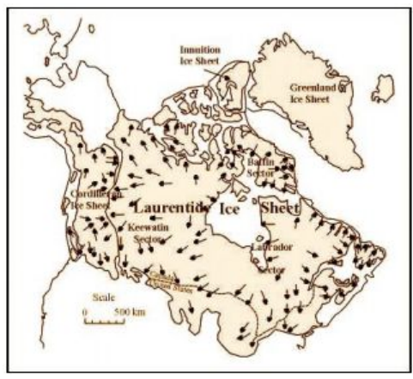
Lab Purpose and Objectives
Although the last glacial maximum (LGM) occurred approximately 20,000 years ago, the modern landscape in North America and many other places around the world contains features left behind from when the glaciers covered a much larger area than at present. Several ice sheets existed in North America during LGM as shown in Figure 1 to the right.
In this lab, we focus on understanding how glaciers shape the landscape and the features that glaciers leave behind after they retreat. We will look at a computer model of glacier flow to examine glacier sensitivity to climate change and depositional features associated with past glaciation.

Part 1: Observing Glacier Flow and Depositional Features
In this section of the lab, you are going to look at a computer model of a glacier that is free to the public through the University of Colorado to get a better understanding of glacier flow and depositional features associated with glaciers. The model is simplified but demonstrates the general behavior of mountain glaciers and allows the user to play with a few tools common to glaciology (the study of glaciers).
1. Go to http://phet.colorado.edu/en/simulation/glaciers . Note- this program requires Java to work and may not be successful on chromebooks.
2. Click the green button that says “Run Now!” to start the model.
3. The model begins with the glacier in a steady state-- the terminus is neither retreating, nor advancing, but the glacier is still flowing. We can tell the ice is flowing if we look at the movement of the little black dots in the ice, which represent rock being carried by the glacier. The ice will flow from the accumulation zone into the ablation zone as time progresses, causing the glacier to deposit till at the terminus.
4. Take a bit of time to explore the tools in the model. The tools in the model are labeled in the figure below. *Make sure you switch from English to metric units, and you click on the box to display the equilibrium line!!! If you need additional tips on how the simulation works, please see the following video - Glacier PhET simulation walkthrough (https://www.youtube.com/watch?v=gX44-wCQNQc).

PhET Geomorphology Glacier Landscapes Lab
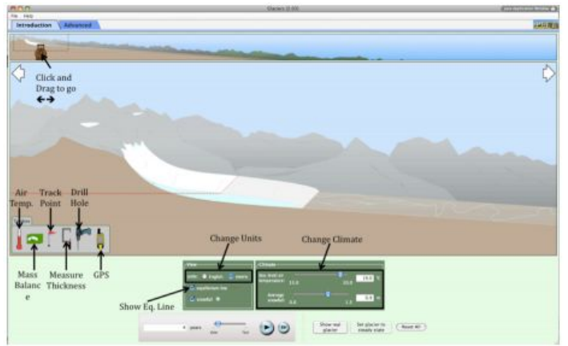
5. Record the length of the glacier by clicking on the GPS unit icon beneath the glacier and dragging it onto the glacier so that the tip of the arrow touches the glacier terminus. The distance measurement on the GPS is the glacier length. Leave the GPS at that location.

Q1: Initial Glacier Length:
_____________________

6. Decrease the air temperature at sea level by 1°C (from 19°C to 18°C). Click and drag on the bear at the top of the screen to move your glacier window down the valley. Wait until the terminus stops advancing, then measure the length of the glacier using a new GPS symbol.
Q2: How much did the length of the glacier change relative to the initial length? Show your numbers and units. You may want to use the scroll bar at the bottom of the screen to speed up the advance to save time.

__________________________________________________________________________________

7. Reset your temperature at sea level to 19°C. Slowly increase your average snowfall (by increments of 0.1 m) until the terminus has advanced to just downhill from the terminus location in part (6). You should still have a GPS marker at the terminus position in (6) to remind you where it was located.
Q3: By how much did you need to change the average snowfall to make the glacier advance approximately the same distance as in (6)? You may want to use the scroll bar at the bottom of the screen to speed up the advance to save time.

_________________________________________________________________________________

PhET Geomorphology Glacier Landscapes Lab

Q4: In your opinion, is the glacier more sensitive to temperature OR precipitation change? Use the changes in temperature and precipitation that you used in (6) and (7), respectively, as support for your answer. Explain why you chose your answer.

8. Use the drill tool to put a borehole in the ice, similar to what happens when an ice core is extracted (click on the red button on the drill tool once you pick your drilling location).
Q5: Watch how the hole deforms with time. Is this what you expected? Use specific examples to explain why.

Q6: Is friction highest at the glacier surface, at the glacier base, or somewhere in between? Is friction lowest at the glacier surface, at the glacier base, or somewhere in between? How can you tell where friction (i.e., ice deformation) is the highest and lowest based on the bore hole you drilled?

Q7: Sketch what the borehole looks like after a short period of time and use it to support your answer to Q5.

PhET Geomorphology Glacier Landscapes Lab

9. Increase the air temperature by 0.1°C so that the glacier retreats up the valley.
Q8: You’ll notice a well-defined line of black/gray at the most-advanced terminus location. What is this line representing? Be specific.

Q9: Describe the sediment that the glacier left behind. Use glacial vocabulary.

10. Use the C clamp tool to measure the thickness of the glacier near the center and at the leading edge.
Q10: What is the thickness of each? Be sure to include units.

_________________________________________________________________________________

11. Increase the air temperature by another 0.1°C to cause additional retreat. Use the C clamp tool to measure the thickness of the glacier near the center and at the leading edge.
Q11: What is the thickness of each? Be sure to include units.

_________________________________________________________________________________

Q12: How does the thickness of the glacier change with an increase in temperature? What do you think would happen if the temperature warmed by 1°C? Explain why.

PhET Geomorphology Glacier Landscapes Lab

12. Now that you have hypothesized about what would happen to the glacier with a 1°C increase in temperature, test it out.
Q13: Record the actual thicknesses (including units) of the glacier near the middle and at the edge below.

_________________________________________________________________________________

Q14: Where is ablation occurring? Feel free to use the module and the available tools within it. Support your answer with evidence from this exploration.

Activity #3: Everything Glaciers!

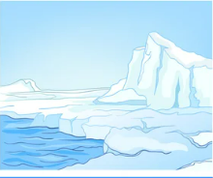
CHOICE A: Glacier Movement
Directions: Your task is to describe how glaciers move. You may accomplish this task in one of several ways. You may create a multi-media piece, write an essay description, draw a picture, compose a poem or song, make a picture collage, script a play, create a comic – have fun & be creative! Include information about advancing, retreating, and stationary glaciers.

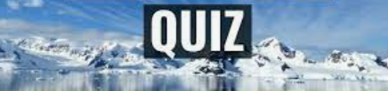
CHOICE B: Create a Quiz on Glaciers
Directions: Your task is to develop a quiz that covers the various topics you have explored about glaciers.

1. Create the quiz and supporting answer key.
2. Your quiz should take approximately 30 minutes to complete and contain both multiple choice and short answer questions.
3. At least one short answer question must be an opinion type (example: how do glaciers impact your life?)
4. Stretch yourself to include a variety of questions – perhaps even a diagram related one!
5. Your quiz can be in hardcopy or digital form (it’s up to you!)

